**Task 2: Set up a server with Nginx/Apache**

Create a simple HTML page using a text editor like Nano or Vim and save it in the appropriate directory for the web server.

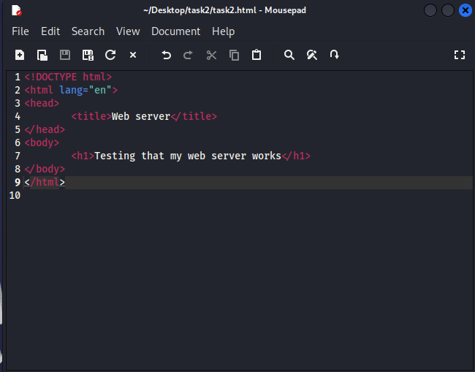

Verify that the web server is working correctly by opening a web browser and navigating to the IP address of the virtual machine or localhost if running the web server on the same machine

Configure the web server to support SSL/TLS encryption and secure HTTP headers.

(install open ssl)

(create ssl certificate and server key)

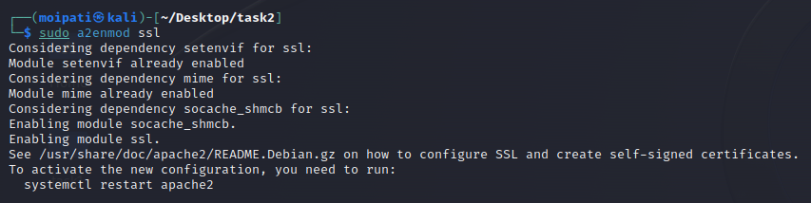(encrypt the ssl)

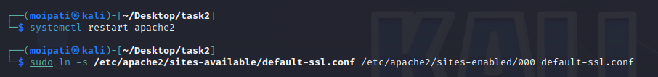(restart the server and change the location of the certificate)



(open the ssl certificate with vim)

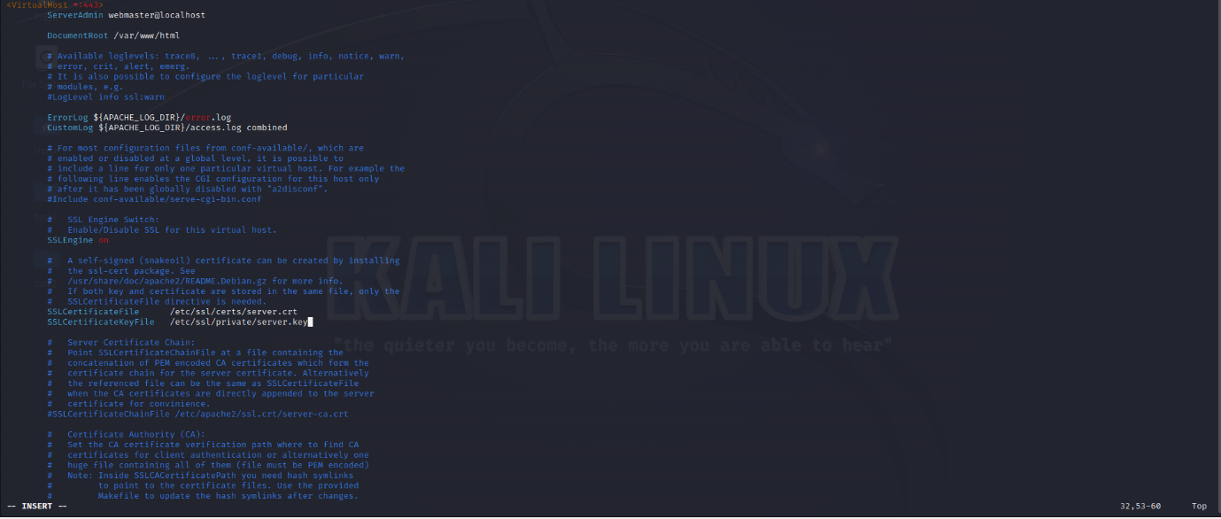(change the location of the ssl certificate)

**Task 3: Harden your server**

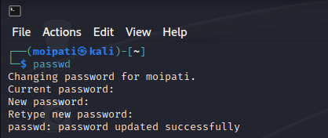

(changing the password)

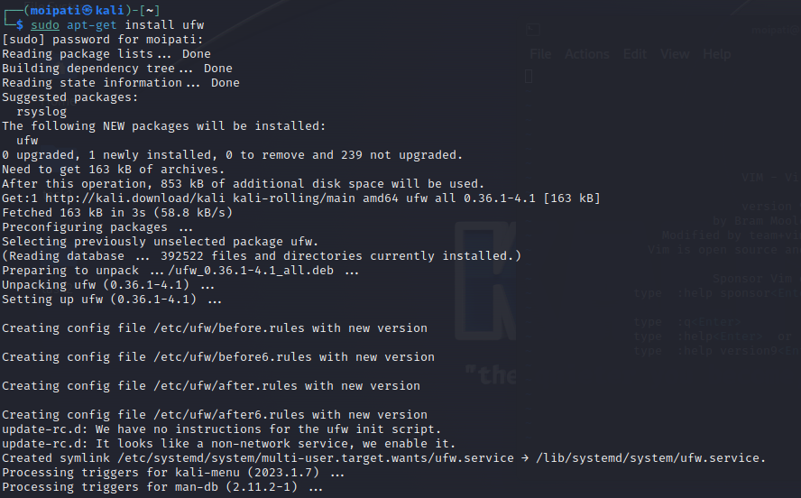

(install ufw to configure the firewall)

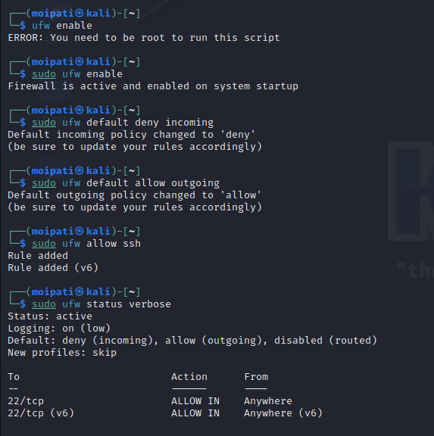

(Configure the firewall)

Disable unnecessary services and applications to reduce the attack surface of the system. I was worried about disabling something important so I just took a screenshot of all of the services and their statuses.

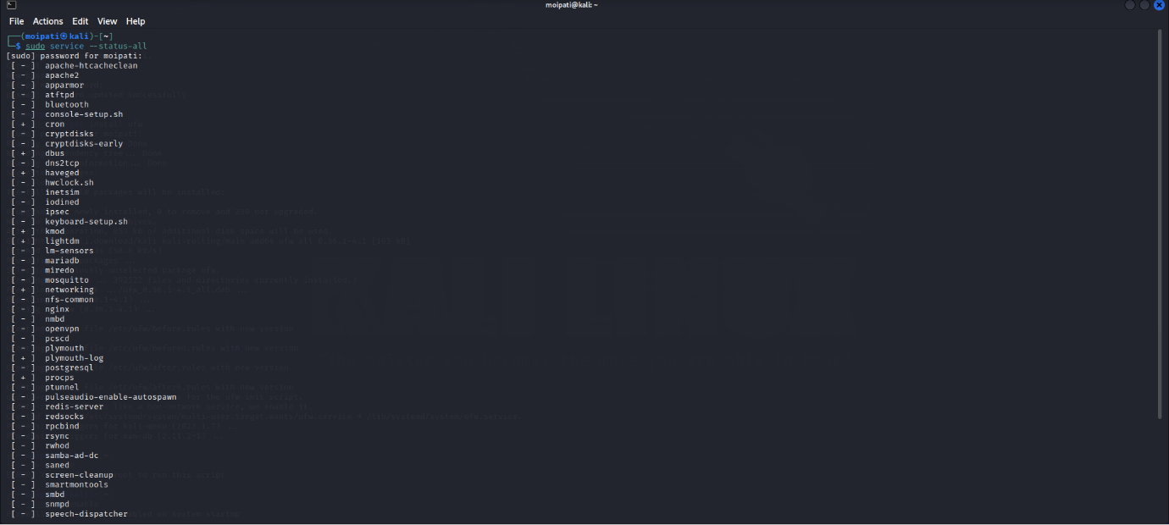

(updating the system)

(install logcheck)

(monitor suspicious activity with logcheck)